RAMS READERS (Fiction)

Name____________________________ Teacher_____________

Title of Book:____________________________ Grade: K

Character (WHO is in the story?) Setting (WHERE does the story happen?)

_______________________________ ______________________________

Problem (WHAT happens in the story?) Solution (HOW does the story end?)

_______________________________ ______________________________

1. Read the story.
2. Draw a picture in each box.
3. 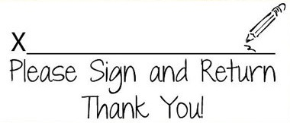Label the picture with 1 or 2 words.
4. Turn the paper into your teacher.